AI ASSISTED CODING

ASSIGNMENT – 1
Task 1: Use Cursor AI to generate a Python class Book with attributes title, author, and a summary () method.
Prompt : “Generate a Python class named Book with attributes title, author, and a method summary() that returns a formatted string with the title and author.”
Code and output :
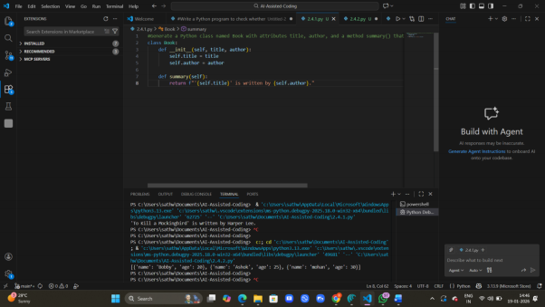

Task 2: Use Gemini and Cursor AI to generate code that sorts a list of dictionaries by a key.
Prompt: Write Python code to sorta list of dictionaries by the key age. Explain the code briefly.
Code and output :

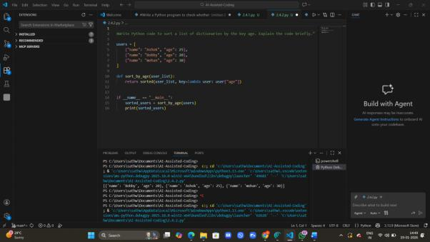

Task 3: Ask Gemini to generate a calculator using functions and explain how it works.
Prompt: Write a Python calculator program using separate functions for add, subtract, multiply, and divide. Then explain how the program works step by step.
Code and Output:
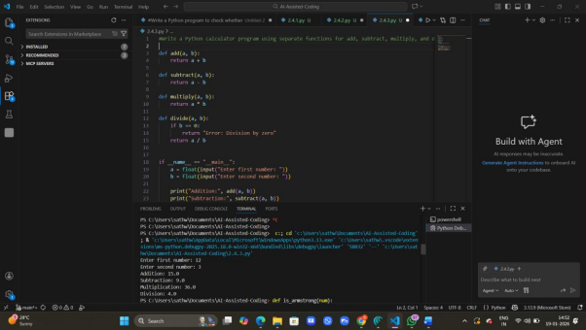

Task 4: Generate an Armstrong number program using Gemini, then improve it using Cursor AI.
Prompt: Write a Python program to check whether a given number is an Armstrong number. Use basic Python constructs and explain briefly.
Code and Input:
